**Automate the Web Application**

**Developer Details:**

N Prasad

BTECH (Department of Computer science and Engineering)

BS Abdur Rahman Crescent Institute of science and technology.

**Contact**: [prasadnithi15@gmail.com](mailto:prasadnithi15@gmail.com)

**Source code:**

Git repository link:🡪 <https://github.com/prasad-ops/project4.git>

**PROBLEM STATEMENT:**

Use the website link given to you and automate different functionalities for the same. Create a new project and include all the dependencies in the class path. Create a Java class that will contain your automation and test scripts. Run the project using TestNG.

* Show a registration form, login, search bar, and add-to-cart automation
* Handle invalid logins and show appropriate error messages in the console
* Fetch the test reports over HTML or Excel
* Document the step-by-step process involved in completing this task

**REQUIREMENTS:**

* Eclipse/IntelliJ: An IDE to code for the application
* Java 8: A programming language to develop the prototype
* Git: To connect and push files from the local system to GitHub
* GitHub: To store the application code and track its versions
* Scrum: An efficient agile framework to deliver the product incrementally
* Specification document: Any open-source document or Google Docs
* TestNG
* Selenium WebDriver

**Git Repository links:**

Git repository link:🡪 <https://github.com/prasad-ops/project4.git>

**ALGORITHM:**

* Start the program.
* Create a new class named RegistrationForm, to automate the registration operations.
* Set system properties as webdriver.chrome.driver and provide the path for it.
* Declare web driver as new chrome driver.
* Provide the URL for automation and testing.
* Perform all the testing operation using selenium code and close the driver.
* Create a new class named LoginForm, to automate login operations.
* Loginform class contains two methods, valid login test and invalid login test.
* Close the driver after execution of each methods.
* Same procedure is followed for search bar testing and add to cart operation
* Appropriate messages are shown in the console.
* The test report are fetched over HTML file.
* The step-by-step process involved in completing this task should be documented
* Stop the program

**HOW TO EXECUTE:**

STEP 1:

Download the code from the git repository

Open the code in sts or eclipse ide.

***Run texing.xml file as (TestNg Suit)***

It will run all the page (Registration form, login form, search bar test, add to cart test)

First, it will run registration form

Here, register button is not clicked finally. Since it will register the given id in database, we need to change the registration id for each testing. Inorder to avoid it. The registration form is displayed and all the datas were entered into the fields without clicking registration button the test output will be registration successful.

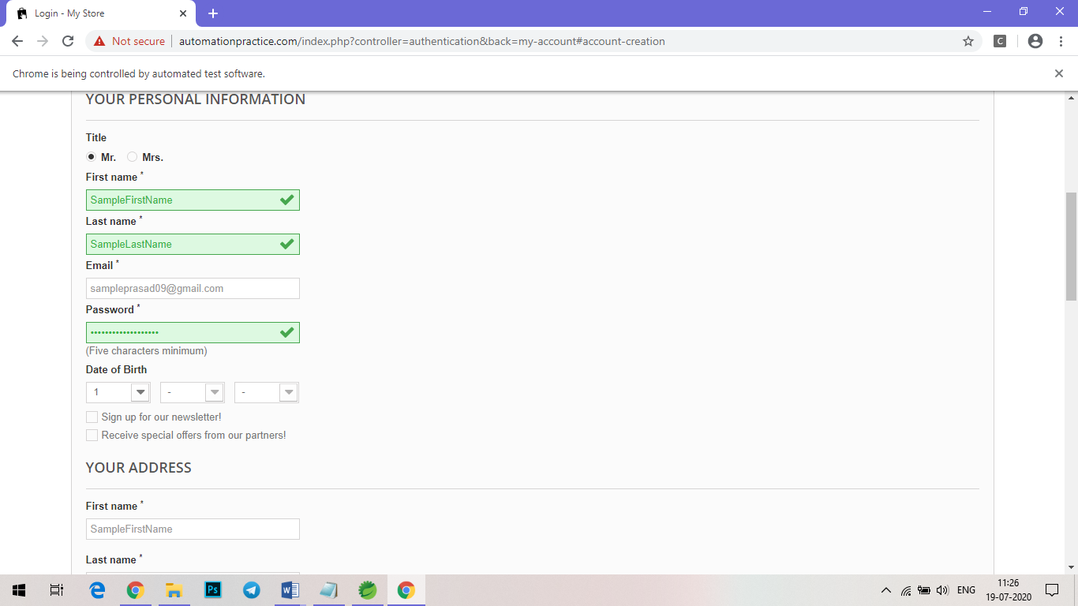

Fig 1. Registration Form.

STEP 2:

After testing registration form, a new browser is opened foe testing login page.

Two testcases were used for login testing.

1. Valid login id 🡪 will navigate into the respective account.
2. Invalid login id🡪 will provide failed authentication statement.

Here, email address and password used for valid login check are

Email address🡪 [project4@gmail.com](mailto:project4@gmail.com)

Password 🡪 [project4@gmail.com](mailto:project4@gmail.com)

For invalid checking the password is changed.

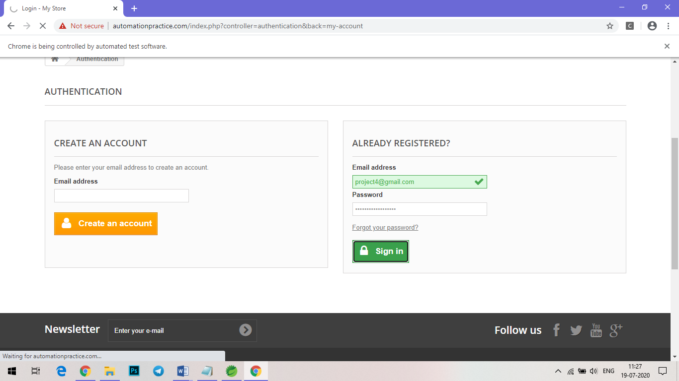

Fig 2. Valid login authentication.

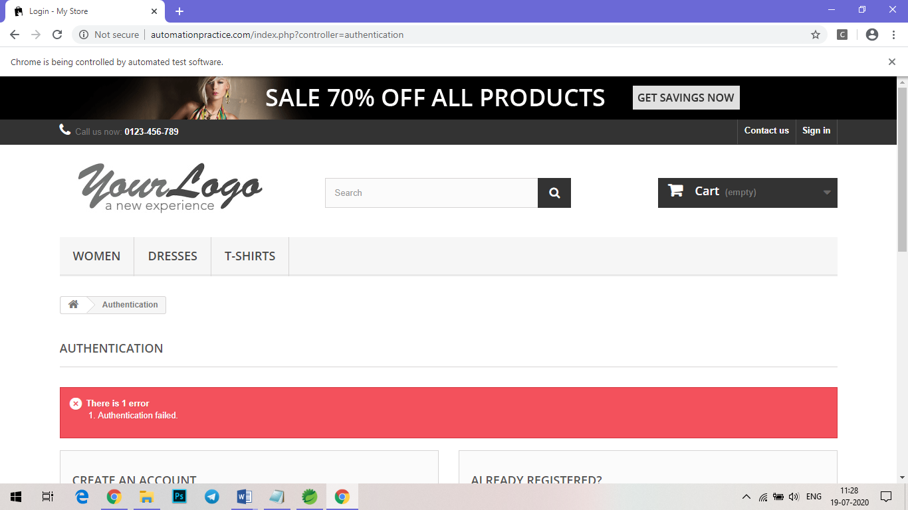

Fig 3. Invalid login authentication.

STEP 3:

For search bar testing

A sample search keyword is used (Evening Dress).

It will displayed all the relevant item belongs to the mentioned keyword.

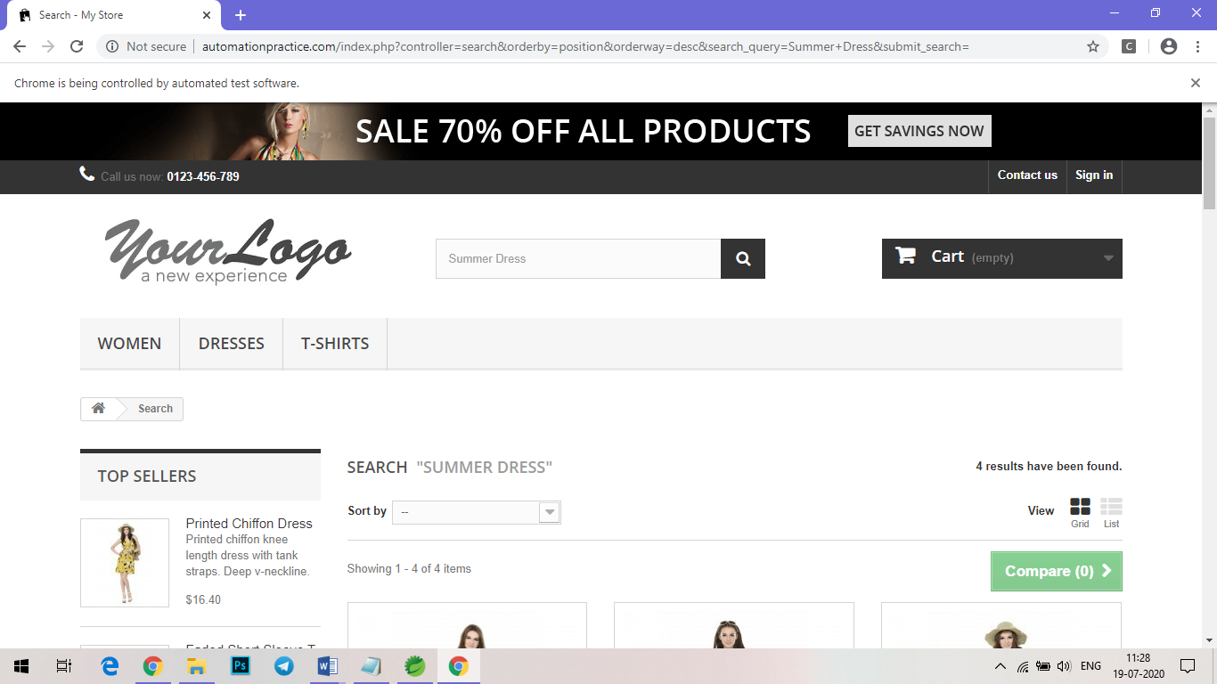

Fig 4. Search bar testing.

STEP 4:

For add to cart automation, 2 sample products are taken and add the product in the cart.

The sample product are (Printed dress, blouse).

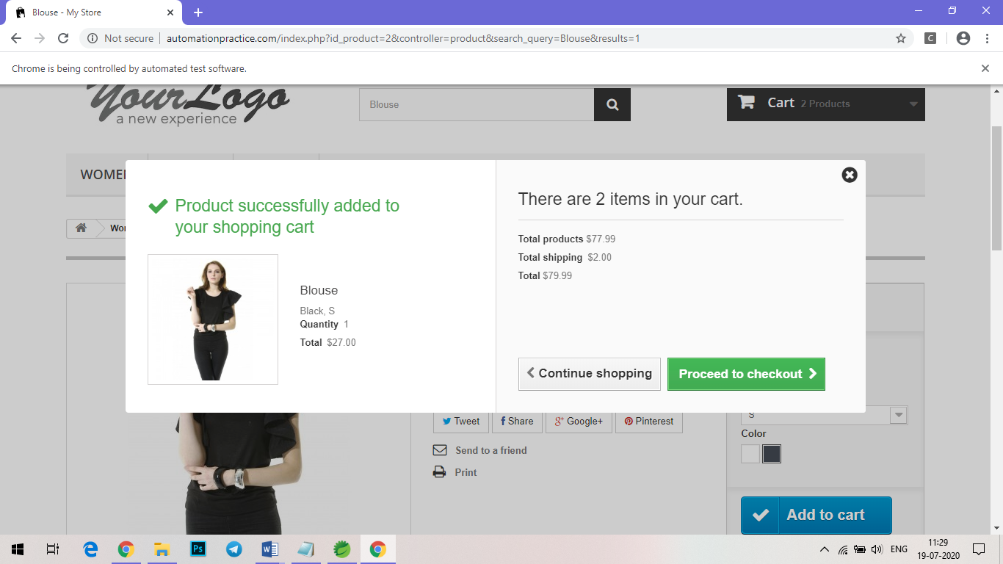

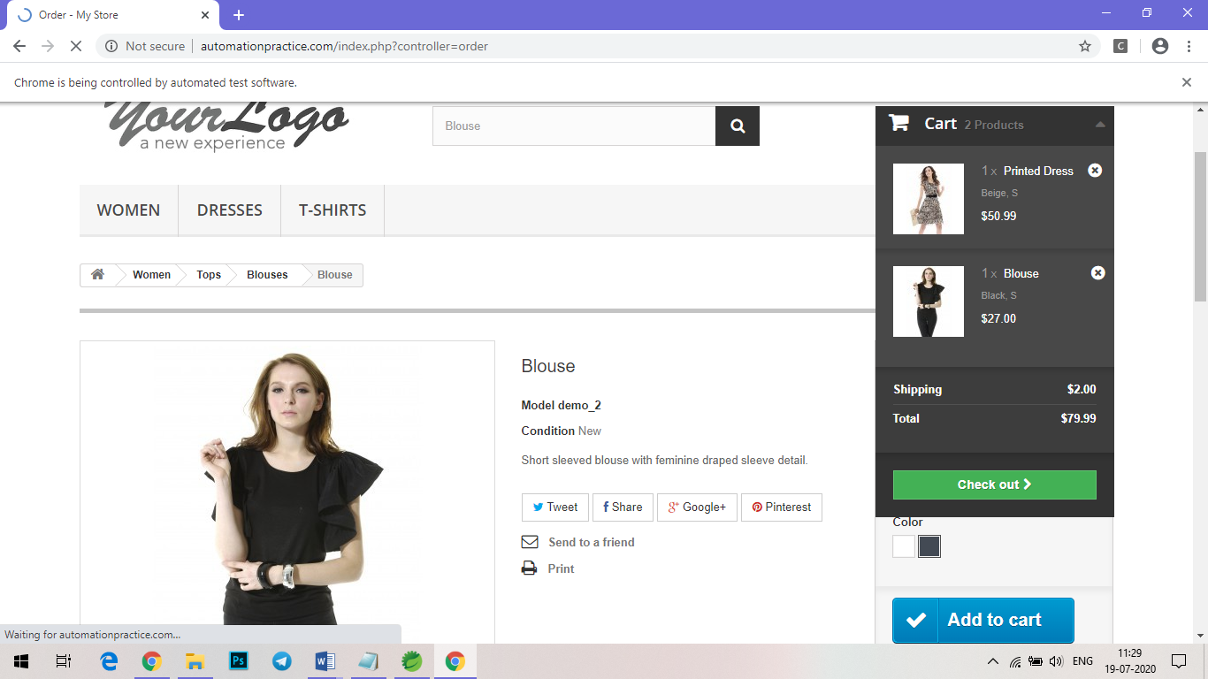

Fig 5. Add to Cart Automation.

STEP 5:

After all the automation process. Check the console for success output.

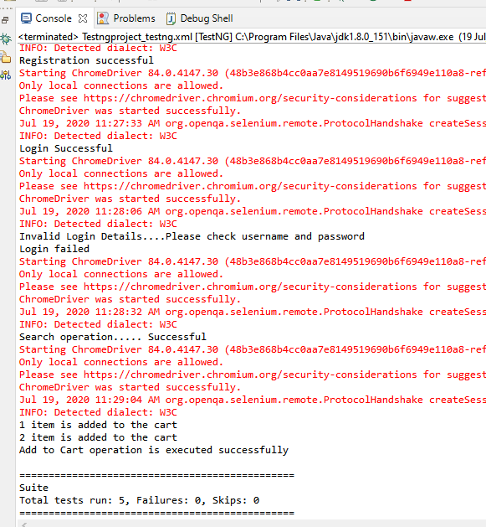

Fig 6. Console output.

STEP 6:

The test report are generated in the form of HTML file

1. emailable-report.html
2. index.html

open both the report with web browser.

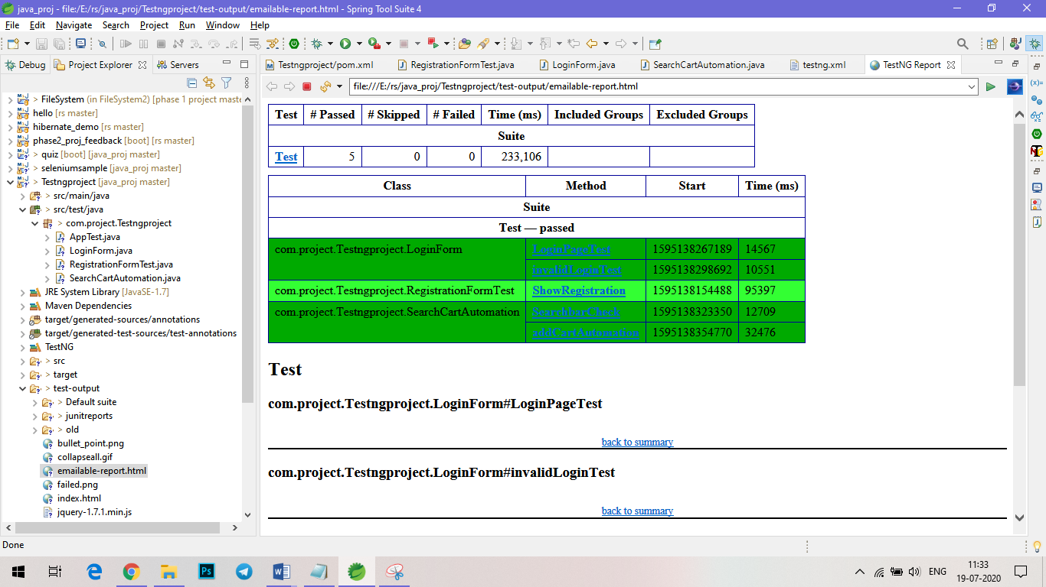

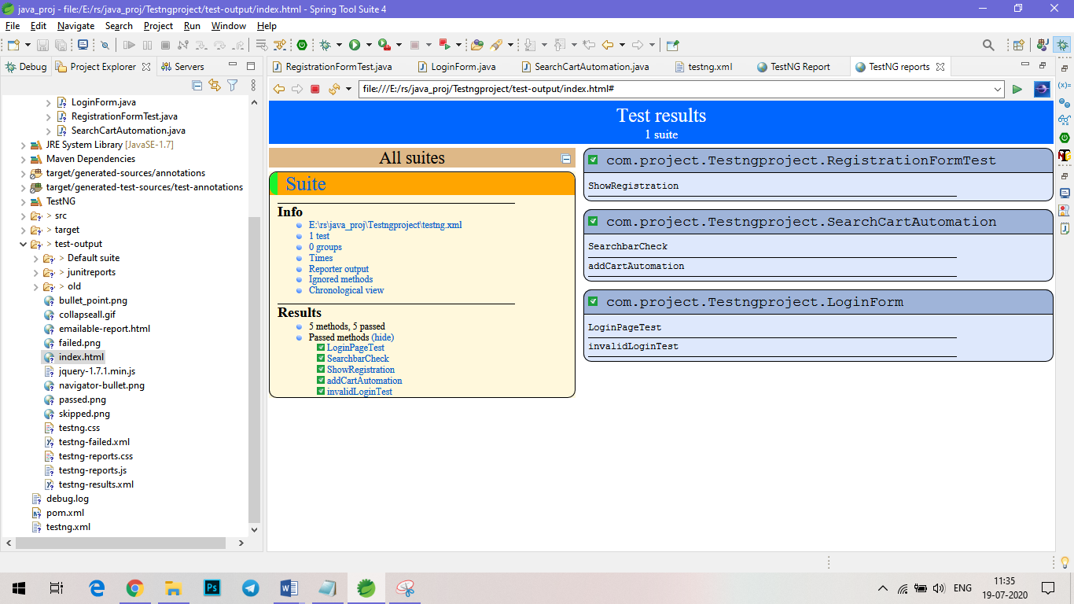

Fig 7. Test Reports.

**CONCLUSION:**

Thus, the mentioned task in the problem statement are executed. The source code is pushed into the git repository. The git link for downloading the source code is given in document. The given website link is automated. The registration form, login form, search bar, add to cart page were tested using selenium Webdriver and TestNG. The test reports are fetched in the form of HTML file. The step by step process involved in completing this task is documented.